In my last article, we talked about the beauty of a chocolate wrapper and the significance its content can hold. A good chocolate wrapper truly is more than just a label for your favorite sweet indulgence.

As I set out to complete part two here, however, I decided to pull out all my bar wrappers (yes, I collect chocolate bar wrappers, true story) because I wanted to look at all the different certifications I’ve seen firsthand before digging into all the available options.

Not surprisingly, I found plenty of USDA Organic, Fair Trade and Rainforest Alliance certifications. But what surprised me was the sheer abundance of other certification schemes. I mean seriously, folks, there are a TON of certifications out there, and it can quickly become a daunting task trying to figure out exactly what your chocolate label is telling you!

From my collection alone, here’s what I found: POD chocolate from Baii was certified Halal. Organic certifications had standards from across the globe - USA, Australia, Canada and Europe. Latin American chocolate growers have an entirely different set of certifications. Some indicators, such as slave-free and direct trade, don’t even come from an official standards organization, but instead are simply communicated by the maker of their label. For these designations, apparently, the honor system works best (yeah, not so sure about that!)

To help make sense of the plethora of certification, let’s take a look at the most common ones and learn what they mean:

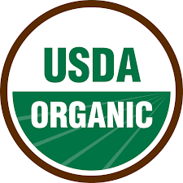
USDA Organic – this certification covers the chocolate from farm to table. It tells us that there was no use of synthetic fertilizers, prohibited pesticides and genetically modified organisms. At least 95% or even more of the content of the chocolate is organic.
https://www.usda.gov/topics/organic
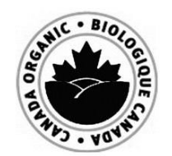

“The Canadian Food Inspection Agency (CFIA) regulates the use of the Canada organic logo. The use of the organic logo is only permitted on products that have an organic content that is greater than or equal to 95% and have been certified according to the requirements of the Canada Organic Regime. The use of the organic logo is voluntary but when used, it is subject to the requirements of the Organic Product Regulations 22 and 23.”

http://www.inspection.gc.ca

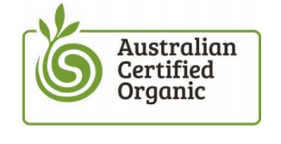
“The term ‘organic’ is not currently regulated under Australian law, meaning that companies/businesses/products are not required to follow specific regulations or a standard in order to claim ‘organic’. This is why it’s important for consumers to always look for ‘certified organic’ and a trusted certification logo, like our Bud logo.
To be certified organic means to grow or manufacture a product free from synthetic pesticides, herbicides, hormones and antibiotics. Livestock must be free to range and pasture-fed, seed must be non-GM, and the process must be water efficient and biodiversity friendly. Producers, processors, manufacturers and retailers of food, drink, fibre, skincare and cosmetics can be certified organic.”
https://aco.net.au/standard/australian-certified-organic/

European Commission of Organic Farming

“The use of the logo and correct labeling is obligatory for all organic pre-packaged food produced within the European Union. In certain cases, it is also possible to use it on a voluntary basis. This means that non pre-packaged organic food produced within the EU or organic products imported from third countries might display the new logo. Next to the new EU organic logo, consumers are informed about a place where the agricultural raw material used in this product have been farmed and a code number of the control authorities is also displayed.”

https://ec.europa.eu/agriculture/organic/downloads/logo_en

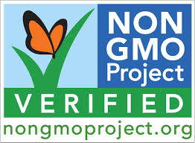

This certification is found on chocolate that has gone through a verification process and ongoing testing. It tells us that the product contains no more than 0.9% GMO. Be aware that, unfortunately, there is nothing like GMO free nowadays.

https://www.nongmoproject.org/product-verification/
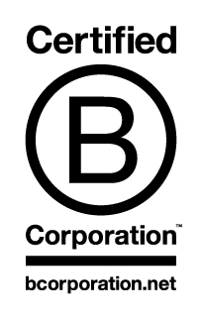

“B Corps are for-profit companies certified by the nonprofit B Lab that meet rigorous standards of transparency, accountability and performance to solve social and environmental problems.
Today, there is a growing community of more than 1,600 Certified B Corps from 42 countries and over 120 industries working together toward 1 unifying goal: to redefine success in business.”
http://www.bcorporation.net
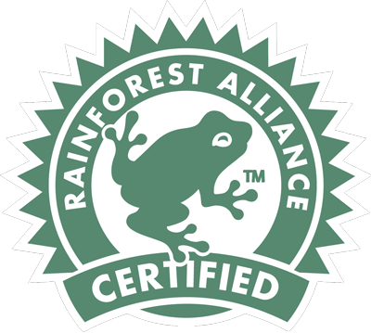

“That little green frog seal assures consumers that products come from farms that are managed to the Sustainable Agriculture Network's (SAN) rigorous standard, which is designed to provide workers and their families with dignified, safe conditions and to protect wildlife and waterways.

The Rainforest Alliance and SAN require that all businesses buying, trading, or mixing products from certified farms must achieve SAN/Rainforest Alliance Chain-of-Custody certification in order to call their product Rainforest Alliance Certified.”

http://www.rainforest-alliance.org/business/agriculture/certification

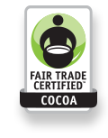

Fair Trade USA

“We seek to empower family farmers and workers around the world, while enriching the lives of those struggling in poverty. Rather than creating dependency on aid, we use a market-based approach that empowers farmers to get a fair price for their harvest, helps workers create safe working conditions, provides a decent living wage and guarantees the right to organize.

Specifically related to cocoa, farmers are often forced to sell their harvest to middlemen who rig scales or misrepresent prices, and media reports of child slavery show the stark contrast between the delicious treat and the difficult conditions of the people who produce it. Fair Trade certification ensures that farmers receive a fair price, allows farmers to invest in techniques that bring out the flavors of the region, and strictly prohibits slave and child labor.”

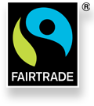

Fair Trade International

When a product carries the FAIRTRADE Mark it means the producers and traders have met Fairtrade Standards. The Fairtrade Standards are designed to address the imbalance of power in trading relationships, unstable markets and the injustices of conventional trade.

https://www.fairtrade.net

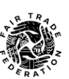

The Fair Trade Federation is a membership organization of businesses who practice 360° fair trade.

http://www.fairtradefederation.org

DIRECT TRADE CERTIFIED (no official certification)

Direct Trade – no predatory middlemen and abusive labor practices. Producers have real, face-to-face relationships with growers who respect the environment and fair labor practices.

Label Example:

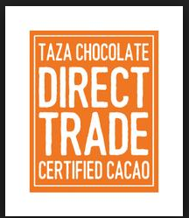

https://cdn.shopify.com

SLAVE FREE CHOCOLATE (no official certification)

Right now, slaves are working on cocoa farms in West Africa.
Many of them are children.

LABEL EXAMPLE:
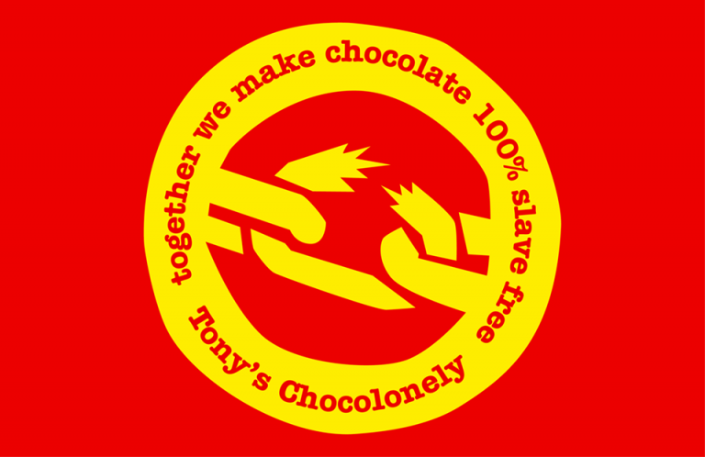

http://www.tonyschocolonely.com

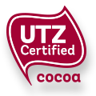

UTZ Certified wants sustainable farming to become the most natural thing in the world. The strict requirements for UTZ certified farms and businesses are closely monitored by independent third parties who assure good agricultural practices and management, safe and healthy working conditions, no child labor and protection of the environment. UTZ tracks and traces cocoa from the farmer to the shelf in the store.
https://utz.org

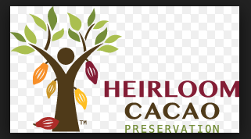

“Launched in 2012 in partnership with the USDA and the Fine Chocolate Industry Association, the Heirloom Cacao Preservation Fund (HCP) formed in response to the global pressures of environmental change, deforestation, and economic influences threatening the world’s supply of high quality, flavorful cacao.

Recognizing these endangered cacao trees are the foundation for not only delicious chocolate, but also the livelihood of many farmers and farming communities, the HCP is the first initiative to identify and map the world of high quality, flavor cacao and certify growers of these endangered trees. As a nonprofit organization, the HCP is committed to improving the lives of the farmers who assist us in protecting and preserving cacao diversity and the chocolate they produce.”

http://hcpcacao.org

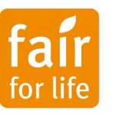

“Fair for Life promotes an approach of Fair Trade that allows all producers and workers who are at a socio-economic disadvantage to access a wider range of social and economic benefits. Fair Trade is part of a broader context of sustainable development within a region that safeguards and supports the local social fabric, particularly in rural settings. These principles hold true equally well in the Global South as the Global North and apply throughout the whole supply chain covering producers, traders, manufacturers and brand holders.”

http://www.fairforlife.org

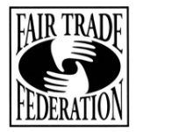

The Fair Trade Federation is a community of businesses dedicated to 360° fair trade. Fair Trade Federation members:
- offer advance payment to artisans and farmers, allowing them to purchase raw materials without taking out high interest loans.
- form long term relationships with artisans and farmers. If a product doesn’t sell, fair trade buyers won’t simply move onto another supplier. Instead, they work with the same producers to develop new products using their existing skills. This means that artisans and farmers can rely on steady, long term income that helps improve their quality of life.
- are committed to the people behind their products. If problems arise, fair trade buyers are actively involved in finding a fair and honest solution.
- set realistic timelines and plan their product lines well in advance. Long production times create healthy work environments and reduce the pressure, stress, and overtime that is often imposed on workers in developing countries.

http://www.fairtradefederation.org

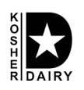

“Kosher” refers to those foods that G-d, in the Torah, has permitted Jews to eat. “Kashrus” refers to the general subject of kosher food. One of the basic principles of kashrus is the total separation of meat and dairy products. Meat and dairy may not be cooked or eaten together.

There are some Kosher symbols that can help to quickly identify dairy ingredients in a pinch. A “D,” or the word dairy, on a label next to a “K” or “U” symbol (usually found near the product name) usually indicates the presence of milk ingredients.

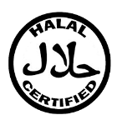

This means that food has been subjected to approved certification systems which guarantee to consumers that nothing in the food has any forbidden components. It is the dietary standard, as prescribed in the Koran. Halal certificates are issued, for a fee, by a certifying body.

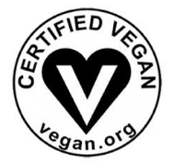

The Certified Vegan Logo is a registered trademark, similar in nature to the kosher mark, for products that do not contain animal products or byproducts and that have not been tested on animals. By ingredients, Certified Vegan products are dairy-free/non-dairy, egg-free, and vegan. However, for those with food allergies, please check with the company on their manufacturing processes for all varieties if potential allergen cross-contamination is an issue for you. Many companies that make vegan products are using shared machinery.

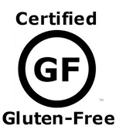

GFCO requires that all finished products using the GFCO Logo contain 10ppm or less of gluten. All ingredients utilized in GFCO certified products are required to go through a stringent review process of approval. Barley-based ingredients are not allowed in GFCO certified products.

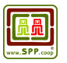

This is the Small Producer Symbol. (SPP - the acronym of the Spanish name, Simbolo de Pequeños Productores ) The SPP is the first Fair Trade farmer-owned certification system, representing the emerging leadership of small farmers in global trade.
http://spp.coop

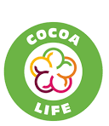

Cocoa Life is a direct trade organization that works with farmers and in the community. Cocoa Life is actively supported on the ground by NGO delivery partners including Voluntary Services Overseas (VSO), Save The Children, CARE International, World Vision and Solidaridad, harnessing their long experience of working with cocoa growing communities to maximize the impact of the program. Cocoa Life also involves experts from organizations like WWF, the UN Development Program, and Anti-Slavery International in the design and oversight of the program.

https://www.cocoalife.org/
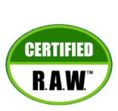

RAWC is a member of the American National Standards Institute (ANSI).
RAWC has developed a standard that aims to verify the claims and support the growth of the raw food community while enabling transparency for consumers, retailers, manufacturers and the regulatory community.

http://www.integrativesystems.org

